**Nodes at given distance in binary tree:-**

Given a binary tree, a target node in the binary tree, and an integer value k, find all the nodes that are at distance k from the given target node. No parent pointers are available.

**Example 1:**

**Input :**

20

/ \

8 22

/ \

4 12

/ \

10 14

Target Node = 8

K = 2

**Output:** 10 14 22

**Explanation:** The three nodes at distance 2

from node 8 are 10, 14, 22.

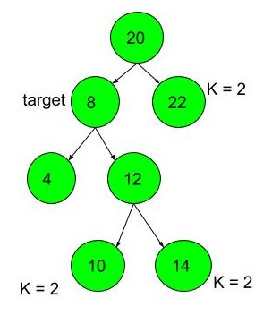

**Example 2:**

**Input :**

20

/ \

7 24

/ \

4 3

/

1

Target Node = 7

K = 2

**Output:** 1 24

**Your Task:**  
You dont need to read input or print anything. Complete the function**KDistanceNodes()** which takes the root of the tree, target and K as input parameters and returns a list of nodes at k distance from target.

**Expected Time Complexity:**O(N)  
**Expected Auxiliary Space:**O(height of tree)

**Constraints:**  
1 ≤ N ≤ 10^3  
1 ≤ data of node ≤ 10000  
1 ≤ target ≤ 10000  
1 ≤ k ≤ 20